Software Specification Document
Project ID/No./Code |  | CipherConnectSDK2 Programmer Guide  For Android User
Ref Document No.
Written by |  | Yifan Wang
Project Name |  | CipherConnectSDK2
Approved by |  | Client |  | Contact Window
Version | Creation Date | Prepared by | Summary of Changes
1.0 | 2016/03/08 | Yifan | Create

TABLE OF CONTENTS
1. Introduction 3
2. CipherConnectSDK Overview/Architecture 4
2.1 Class diagram 4
2.2 Class Description 5
2.3 activity diagram 6
2.4 sequence diagram 8
3. CipherConnectSDK2 -API List 10
4. API Help 11

CipherConnectSDK2

Introduction
CipherConnectSDK2 is designed for CipherLab cordless scanners to work as an input device for the Android Mobile, enabling intensive data collection via Bluetooth Serial Port connection.

Note : The mobile platform must be Android 4.x(or plus)

CipherConnectSDK2 Overview/Architecture

Class diagram
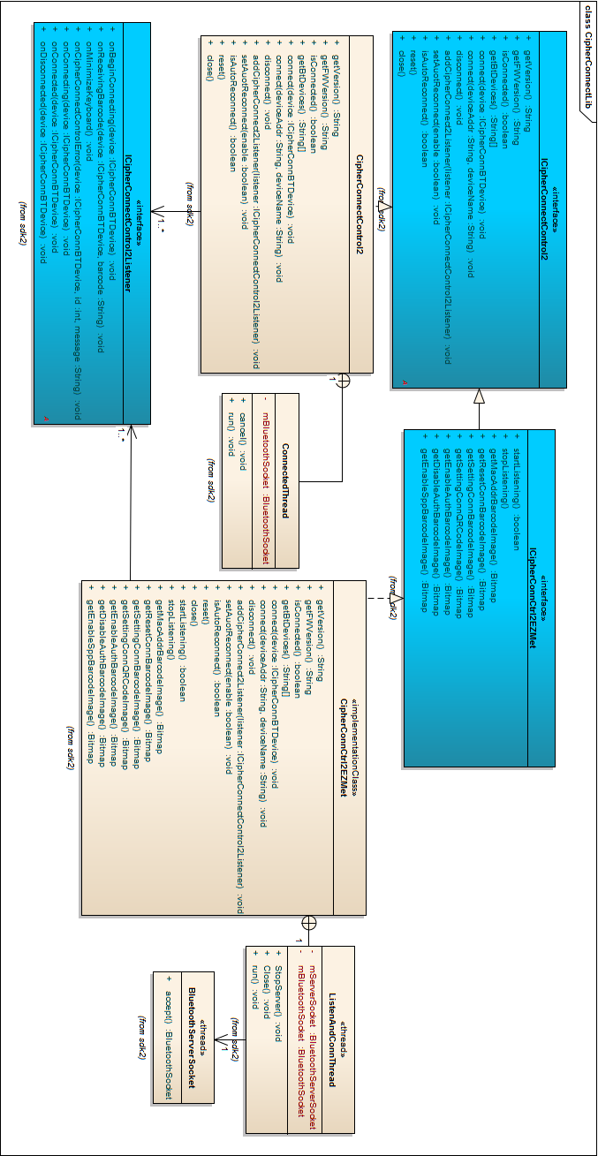

Class Description
Class Name | File | Description
ICipherConnectControl2 | CipherConnectSdk2.jar | Define all methods for master mode connection use.
CipherConnectControl2 | CipherConnectSdk2.jar | Implement all ICipherConnectControl2 methods. User should use to instantiate an object to call the methods.
ICipherConnCtrl2EZMet | CipherConnectSdk2.jar | Define all methods for slave mode connection use.
CipherConnCtrl2EZMet | CipherConnectSdk2.jar | Implement all ICipherConnCtrl2EZMet methods. User should use to instantiate an object to call the methods.
ICipherConnectControl2Listener | CipherConnectSdk2.jar | To listen all events from ICipherConnectControl2 and ICipherConnCtrl2EZMet instances.

Activity diagram
- Slave mode connection
The scanner is under slave mode and an Android device connect to it.
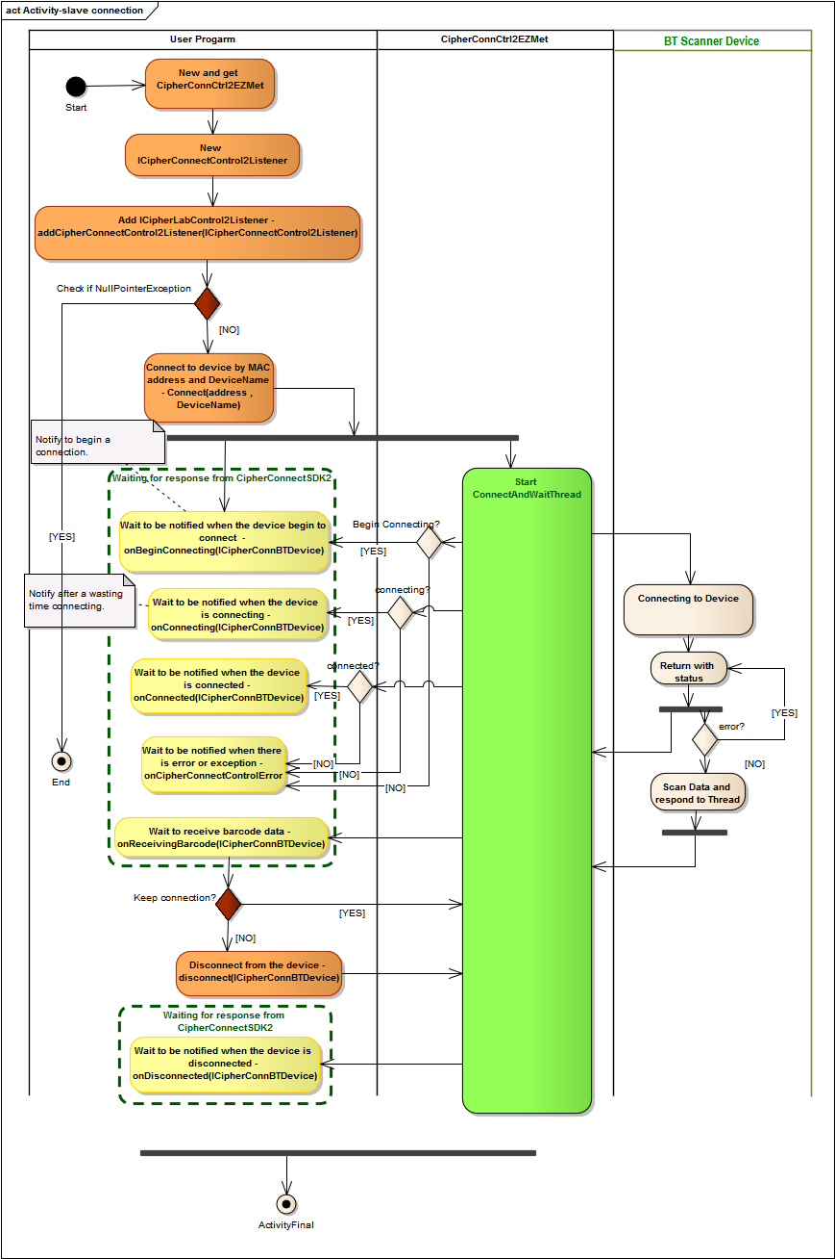
- Master mode connection
Set the scanner to master mode and an Android device wait a connection from it.
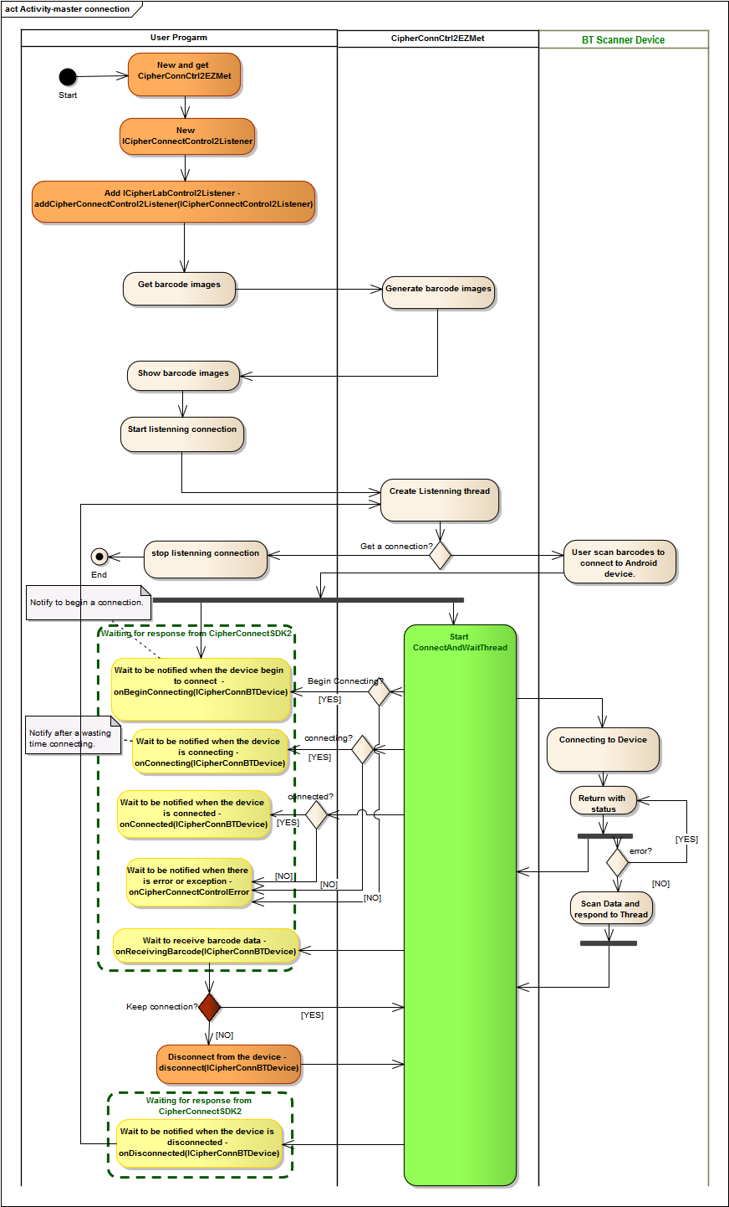

Sequence diagram
- Slave mode connection
The scanner is under slave mode and an Android device connect to it.
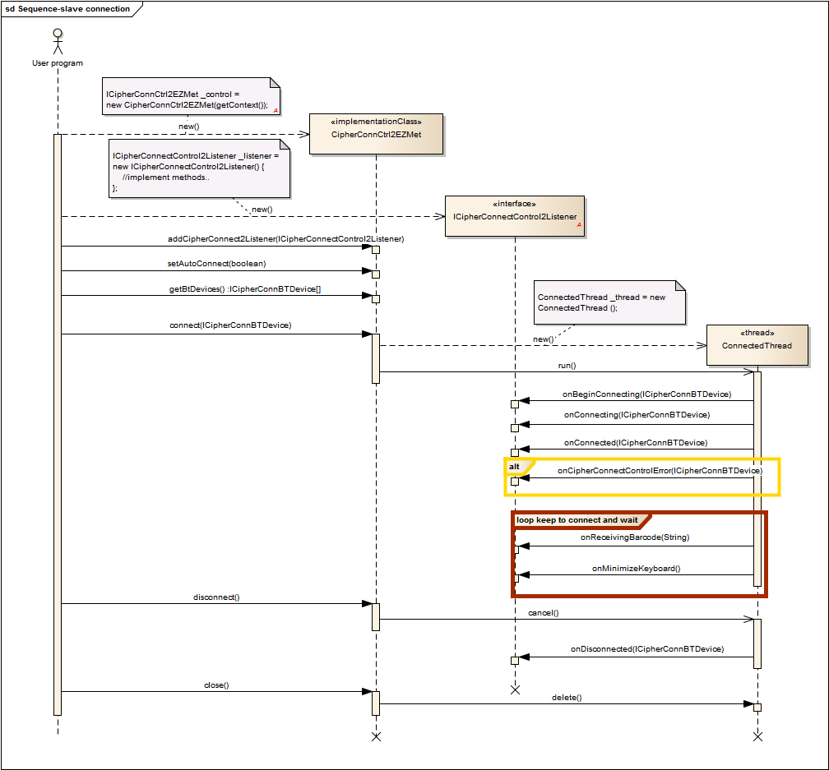

- Master mode connection
Set the scanner to master mode and an Android device wait a connection from it.
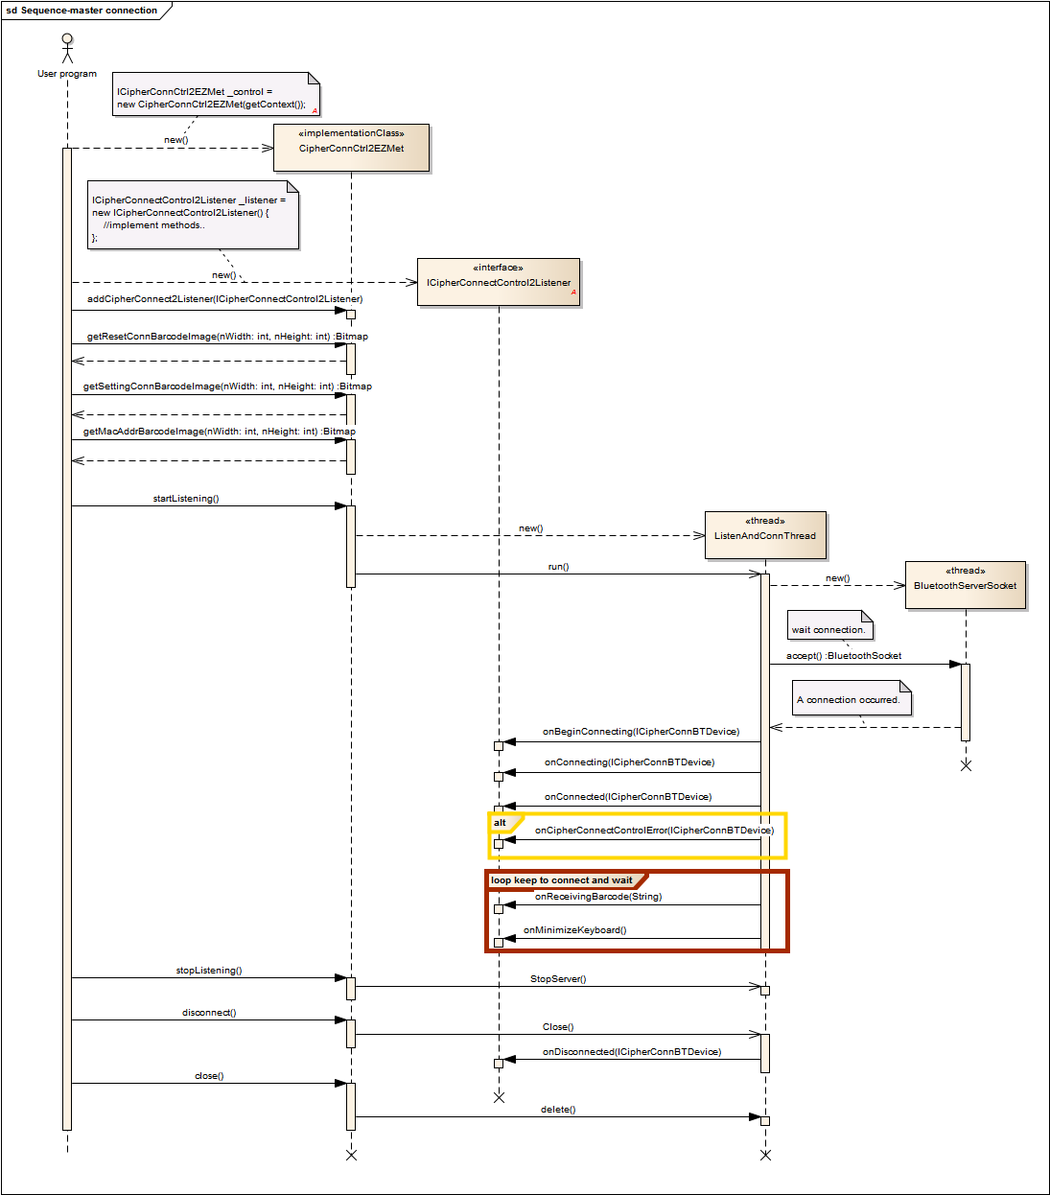

CipherConnectSDK2 -API List
Name | Note
ICipherConnectControl2
getVersion | Get the version of CipherConnectControl2.  String version = _control.getVersion();
getFWVersion | Get the connected device firmware version.  String version = _control.getFWVersion();
isConnected | Get the connection status.  boolean bConnect = _control.isConnected();
getBtDevices | Get all Bluetooth devices which have been identified with the OS.  ICipherConnBTDevice[] devices = _control.getBtDevices();
connect | Connect to the BT scanner device.  try{  _control.connect(device);  }  catch(NullPointerException e){  System.out.println(e);  }
connect | Connect to the BT scanner device by name and MAC address.  try{  _control.connect(deviceName, deviceAddr);  }  catch(NullPointerException e){  System.out.println(e);  }
disconnect | Disconnect from the BT scanner device.  _control.disconnect();
addCipherConnectControl2Listener | Monitor all events from CipherConnectControl2.  try{  _control.addCipherConnectControlListener(  new ICipherConnectControlListener(){  public void onReceivingBarcode (String deviceName,final String barcode) {  System.out.println("onReceivingBarcode [deviceName="  +deviceName+",barcode="+ barcode+"]");  }  public void onCipherConnectControlError (String deviceName,int id,String message) {  System.out.println("onCipherConnectControlError [deviceName="  +deviceName+",id=”+id+”,message="+message+"]");  }  public void onConnecting(String deviceName) { System.out.println("onConnecting[deviceName="  +deviceName+"]");  }  public void onConnected(String deviceName) { System.out.println("onConnected[deviceName="  +deviceName+"]");  }  public void onDisconnected(String deviceName) { System.out.println("onDisconnected[deviceName="  +deviceName+"]");  }  });  }  catch(NullPointerException e){  System.out.println(e);  }
setAutoReconnect | Set auto Reconnect (for master mode connection).  try{  _control.setAuotReconnect(true);  }  catch(NullPointerException e){  System.out.println(e);  }
reset | Clean previous connection status such as firmware version, scanner name .. etc.  _control.reset();
close | CipherConnectControl2 object should be closed before leaving service.
ICipherConnCtrl2EZMet
startListening | start to listen connection from remote device.  _control.startListening();
stopListening | stop listening from remote device.  _control.stopListening();
getMacAddrBarcodeImage | Generate code128 barcode bitmap to show MAC address for CipherLab scanner use.  Bitmap img = _control.getMacAddrBarcodeImage(nWidth, nHeight);
getResetConnBarcodeImage | Generate code128 barcode bitmap to reset connection command for CipherLab scanner use.  Bitmap img = _control.getResetConnBarcodeImage(nWidth, nHeight);
getSettingConnBarcodeImage | Generate code128 barcode bitmap to set connection command for CipherLab scanner use.  Bitmap img = _control.getSettingConnBarcodeImage (nWidth, nHeight);
getSettingConnQRCodeImage | Generate QR code bitmap to setting connection command for connecting CipherLab scanner use.  Bitmap img = _control.getSettingConnQRCodeImage (nWidth, nHeight);
getEnableAuthBarcodeImage | Generate code128 bitmap to enable authentication command for CipherLab scanner use.  Bitmap img = _control.getEnableAuthBarcodeImage (nWidth, nHeight);
getDisableAuthBarcodeImage | Generate code128 bitmap to disable authentication command for CipherLab scanner use.  Bitmap img = _control.getDisableAuthBarcodeImage (nWidth, nHeight);
getEnableSppBarcodeImage | Generate code128 bitmap to enabling slave/spp command for CipherLab scanner use.  Bitmap img = _control.getEnableSppBarcodeImage (nWidth, nHeight);
ICipherConnectControl2Listener
onCipherConnectControlError | The user program will be notified when the exception or error occurs in CipherConnectControl2 while it is executing.  Exception message list is follows:  0, Exception message.  101, Please turn on Bluetooth  102, Cannot find any Bluetooth device  103, Cannot find [device-name]  104, Cannot turn off Bluetooth  105, Bluetooth connection error  106, The device is not CipherLab product  107, Cannot find any listener
onBeginConnecting | The user program will be notified while CipherConnectControl2 and CipherLab scanner are beginning to connect.
onConnecting | The user program will be notified while CipherConnectControl2 and CipherLab scanner are connecting.
onConnected | The user program will be notified while CipherConnectControl2 and CipherLab scanner are connected.
onDisconnected | The user program will be notified while CipherConnectControl2 and CipherLab scanner are disconnected.
onReceivingBarcode | The user program will be notified When CipherLab scanner device sends the barcode data.
onMinimizeKeyboard | The user program will be notified When CipherLab scanner device sends minimize keyboard command.

